A Review on Google Lens Clone using Image Recognition

Abstract—
Rishi Goyal, Ridhvi Kulshrestha, Richa Garg, Ishan Jain, Priyansh Sharma¹, Ms. Sonam Gaur²
¹Students, IIIrd Year, Department of Computer Science and Engineering
²Assistant Professor, Department of Computer Science and Engineering
Sonam.gour@poornima.org
Google Lens is an AI-powered technology that uses your smartphone camera and deep machine learning to not only detect an object in front of the camera lens, but understand it and offer actions such as scanning, translation, shopping, and more. Lens was one of Google's biggest announcements back in 2017, and a Google Pixel exclusive feature when that phone launched. Since then, Google Lens has come to the majority of Android devices. Google Lens enables you to point your phone at something, such as a specific flower, and then ask Google Assistant what the object you're pointing at is. You'll not only be told the answer, but you'll get suggestions based on the object, like nearby florists, in the case of a flower.

Other examples of what Google Lens can do include being able to take a picture of the SSID sticker on the back of a Wi-Fi router, after which your phone will automatically connect to the Wi-Fi network without you needing to do anything else. Yep, no more crawling under the cupboard in order to read out the password whilst typing it in your phone.

Index Terms — Image Processing, Image classification, Mobile App, Google Lens (“GOOG”), Accuracy.

I. INTRODUCTION

At present, mobile phone is an important role in our life for communication like calling, messaging etc. Mobile phone replaces numerous of electric and electronic devices in our life nowadays because, all the features are already available in mobile phone. Here we quote a few numbers of examples such as clock, alarm, notes, calculator, telephone directory, calendar, FM radio, music player, memo, camera, photo album and so on. Currently whenever we are in need of the previous devices, MOBILE PHONE is much more enough to all the process. Also in smart phones, there are add up to quantity of preferences whatever we can do it computers. But in this paper, the mobile app, called as Google Lens acts as an image classifier using artificial intelligence and vision techniques. In the concept of image classification or clustering, we need dataset for both training and testing phase, a better algorithm is one which gives higher accuracy and software or tools to implement.[2] Now, the mobile app, Google Lens can replace all the image processing steps such that there is no need of training phase, algorithm and software. This paper provides a proposal about Google Lens as a classifier in the concept of image classification. The rest of this paper is organized as follows. Current scenario in IC is explained in detail with some recent research as examples in section 2. Google Lens as an Image Classifier is described in section 3 and section 4 draws the Results and analysis while Conclusion of the paper with possible tracks of lines to future presented in section 6.

II. CURRENT SCENARIO IN IMAGE CLASSIFICATION

Usually the images are classified according to their attributes like color, size, shape, texture etc. and finally grouping them in to similar group as much as can. Image processing plays an important role in extracting useful information from images.[4] Image processing includes the process of translating an image into a statistical distribution of low-level features is a complicated task since the acquired image data often noisy, and target objects are influenced by lighting, intensity or illumination. Image processing is an essential step for CA plant type’s identification in the case of flower classification. The classification of flower images is built on low-level features like texture and color in order to identify image content. Normalized color histogram is used to describe Color features while gray-level co-occurrence matrix is used to describe texture features.

Image classification is done as shown in the following figures where the major steps of supervised and unsupervised classification are explained respectively.

Steps:
1. Design image classification pattern: state information classes such as urban, agriculture, forest areas, etc. Review field studies to collect basic and secondary data of the study area.

2. Image Preprocessing, including corrections, enhancement and initial image clustering

3. Select representative areas on the image to analyze results of the initial clustering or to generate training signatures.

4. Image classification
a. Supervised mode: using training signature
b. unsupervised mode: image clustering and cluster grouping.
5. PP: finishing geometric correction and filtering along with classification decorating.[1]
6. Accuracy assessment: comparing classification results with results from field studies.

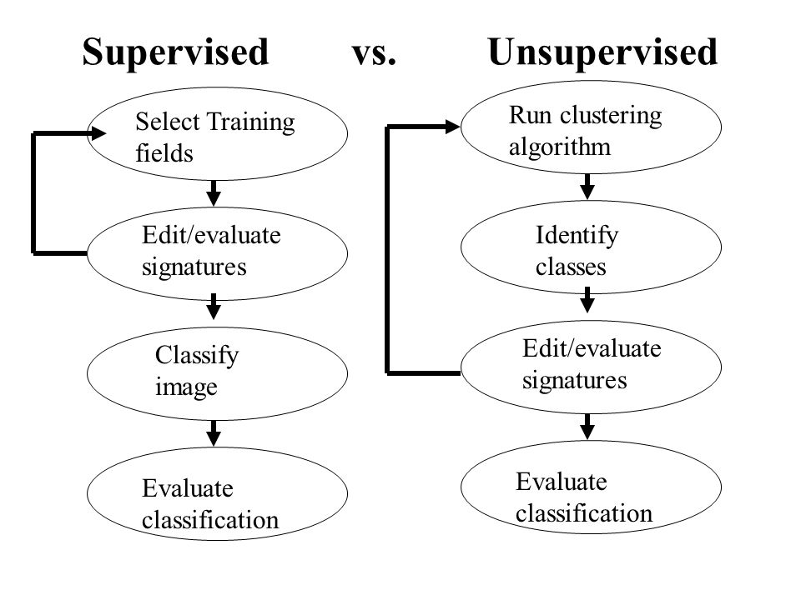
Figure 1: Image classification

III. GOOLE LENS AS AN IMAGE CLASSIFIER

Google announced Google Lens, with which Google can "understand what we're looking at and help us take action," CEO Sundar Pichai said. "We can give you the right information in a meaningful way." New Google's Lens enables users to search with their phone's camera. Its augmented reality further than photo filters. Google launched Lens at first in the Assistant, its digital helper software, and in Google Photos. It will be available at an unspecified date "later this year." Google’s new Lens tool is perfect for image classification as can be understood from the statements of Google CEO Sundar Pichai at Google’s I/O conference that will be available for Google Assistant and Google Photos users. Google Lens is expected to understand, and state, exactly what is in a given photo. By using computer learning, Lens will be able to make analysis of the images and provide real-time information and suggestions. As a demo, he showed the tool labeling a photo of a flower.[6]

The feature provided types the flower is likely to be and also suggested a closely florist. Sundar Pichai noted that these machines can learn and function. Google’s image-recognition technology has enhanced noticeably. In such a way that it can decide what is in a given image with more accurate than its user. It is stated as once we add the pictures either from gallery (database) or capturing through camera in mobile, Google Lens give the details about the image. For example, we add the picture of Lilly, the Google Lens return the attributes of Lily like color and type as shown in figure 4. So we can extract the features from images and classify the images as it belongs to which group. Google Lens can do the classification tasks very efficiently. The steps involved in Image Classification using Google Lens are below.

1. Add the flower image (From DB or Capturing via Camera).
2. Get the images attributes and its group.
3. Store the image as per its group.

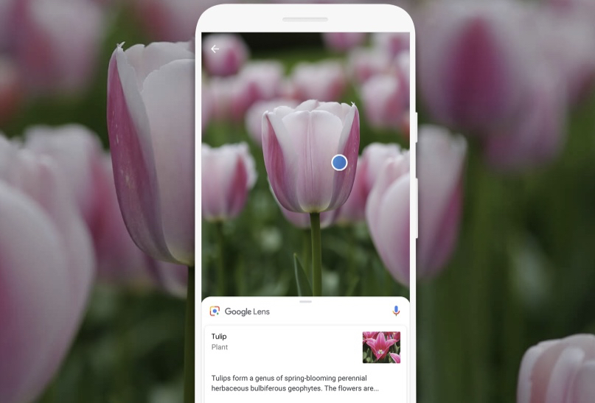

Figure 2: Flower recognition using google lens

IV. RESULTS AND ANALYSIS

Whenever we are using classification algorithms, the result is in the terms of accuracy. Normally, the accuracy is varying from algorithm to algorithm and datasets to datasets as well as tool to tool. [7] So Google Lens can be the best Image classifier. Google Lens App is download from Google Play Store in Samsung J7 and experiments were conducted. While using Google Lens for image classification, we found different categories of results. It is perfectly classified the images which are captured via Google Lens in mobile. For example mangoes and coconut images are captured and the results are flawlessly matched and shown in Figure 5 and 6 respectively.

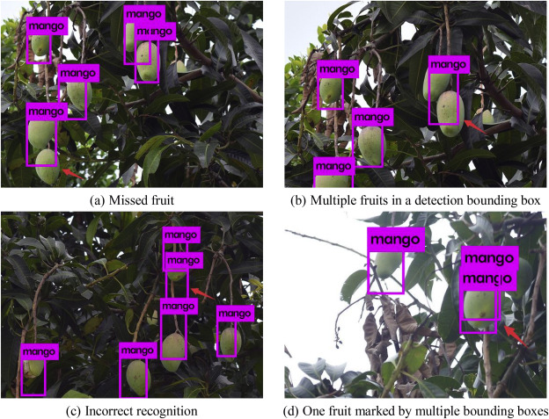

Figure 3: Detection of species of mangoes

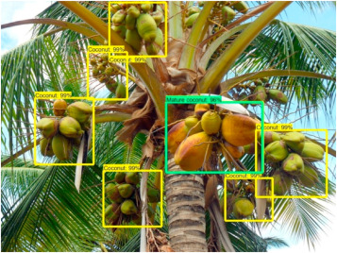

Figure 4: Classification of coconuts using google lens

Accordingly Google Lens advantages and disadvantages are described with the few discriminating examples which were fronting in analysis. For the above example, the drawbacks of Google Lens can be improved by its feature selection algorithms and training of classification algorithms. Because Feature selection algorithm selected the most relevant features of images and training the datasets by classification to be effective.

Abbreviation Table:

Abbreviation | Meaning | Page No
I/O | Input and output | 2
PP | Post- Processing | 2
DB | Database | 2
IC | Image Classification | 1
CA | computer-aided | 1
AI | Artificial Intelligence | 3
ML | Machine Learning | 3

Discussion
We have discussed about the different applications of google lens like detecting flowers, coconut etc. It is also use to recognize the face expression of the person and the bar code reading can also be done by google lens. We have implemented the google lens clone which work as same as the real app provided by google. It also covers other fields of AI and ML like text recognition etc. Many android apps implement google lens which makes the app more interactive and amazing.

Conclusion
In this paper, we have proposed the latest Mobile App, Google
Lens as an Image Classifier explored for the purpose of mangoes and coconut classification. It is observed that using the Google Lens can achieve relatively a good classification accuracy when compared to any other available features. We have developed a new database of 20 classes of mangoes, each class contains 150 mangoes images and experimented images of different datasets size we recorded the size effect on the classification accuracy. The experimental results have shown that using combined features outperforms any individual feature. It is a hope that the image processing task in this study will be further enhanced or new methods will be applied to obtain better representation of the feature extraction. In order to further improve, the study of using the other samples into account can be considered.

References
[1] D.S. Guru et.al., “Textural features in flower classification”, Mathematical and Computer Modelling, Elsevier, Volume 54, Issues 3–4, August 2011, Pages 1030–1036
[2] Dr.S.M.Mukane et.al, “Flower Classification Using Neural Network Based Image Processing”, IOSR Journal of Electronics and Communication Engineering (IOSR-JECE) e-ISSN: 2278-2834,p- ISSN: 2278-8735.Volume 7, Issue 3 (Sep. - Oct. 2013), PP 80-85.
[3] Fadzilah Siraj et.al., “Flower image classification modeling using neural network”, International Conference on Computer, Control, Informatics and Its Applications (IC3INA), IEEE Xplore 2015.
[4] http://nymag.com/selectall/2017/05/google-lens-photo- tool-can-identify images-and-offer-info.html
[5] https://www.cnet.com/news/google-lens-is-augmented- ar-you-can-actually use-snapchat-facebook-instagram/
[6] http://fortune.com/2017/05/17/google-lens/
[7] https://create.arduino.cc/projecthub/crispylol/food-detector-6178c

